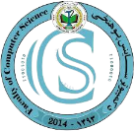

Sami Rasa

4th Year student

**Student ID:** 000-000-000

**Class:** 4th

**Issue Date:** 04/23/2020

**Expiration Date:** 04/23/2024



Signature Authority

Job Position

* Faculty terms and conditions
* Faculty terms and conditions Faculty terms and conditions.
* Faculty terms and conditions Faculty terms and conditions



123 street address, City State, Zip Code

email@kandahar university@gmail.com

123-456-7890, 444-555-COMP

<https://www.kandahauniversityr>.com